CYBR 343 Test3
Instructions:
- Type or write your answers directly below each question.
- Show all work and clearly explain your reasoning.
- Each response must be 4–8 lines in complete sentences.
- Include a screenshot for every question showing supporting evidence.
- Place each image directly under the response.
- Ensure all images are clear and properly oriented.
- Submit via Blackboard only. Email submissions are not accepted.
- I am available for questions until Friday 2:00 PM only.
- No credit without both explanation and screenshot evidence.

Q1. 30 Points
Using Registry Ripper and the provided SAM and SYSTEM registry hives obtained from a computer, answer the following:
- Identify the user who has completed their security questions.
- What is the username?
  - The username is BlueStar [User 1004]
- What security questions are configured?
  - The following questions are configured as security questions:
    - What was your first pet’s name?
    - What’s the name of the city where you were born?
    - What was your childhood nickname?
- What are the corresponding answers?
  - Q1: BlueCat
  - Q2: BlueCity
  - Q3: Blue
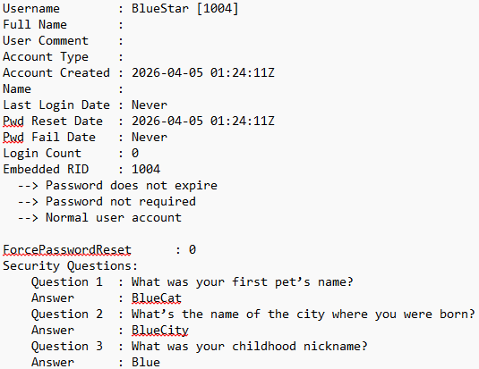
- Determine the network configuration for the system.
- What IP address is assigned to the Ethernet interface?
  - 10.0.2.15
- What is the DHCP server address?
  - 10.0.2.2
- What are the lease obtained and lease expiration times?
  - Lease Obtained Time: 2026-04-05 @ 00:57:41Z (UTC)
  - Lease Expiration (Terminate) Time: 2026-04-06 @ 00:57:41Z
- Include any additional relevant network details.
  - Subnet Mask: 255.255.255.0
  - Lease duration: 24 Hours
  - DHCP is enabled 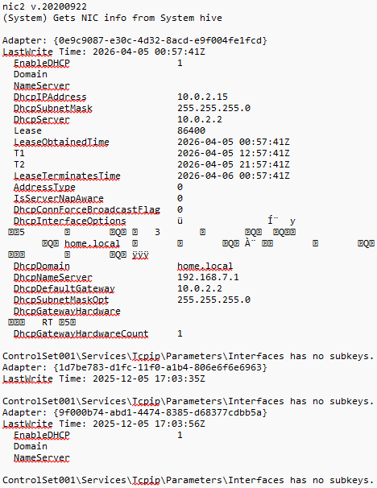
- Identify evidence of program execution.
- When was ipconfig.exe executed?
  - ipconfig.exe was last executed on 2025-09-15 @19:41:16
- When was Diskview64.exe executed?
  - Diskview64.exe was last executed 2025-12-06 @00:35:07
- Determine the last system shutdown time.
  - The last system shutdown was on 2026-04-05 @00:51:11 UTC
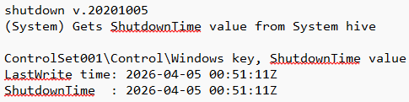

Q2. 30 Points
Using Registry Ripper and the provided NTUSER.dat hive, answer the following:
- Identify the user associated with this NTUSER.dat file.
  - The user associated in the NTUSER.dat file is admin123
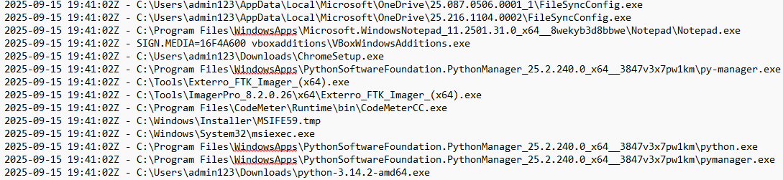
- List the different commands executed by this user.
  - The following commands were executed by this user:
    - Notepad – 2026-04-05 @22:15:36
    - RegRipper – 2026-04-05 @22:14:16
    - Windows Explorer – 2026-04-05 @22:06:39
    - FTK Imager – 2026-04-05 @22:06:29
    - RegRipper – 2026-04-05 @01:07:19
    - Chrome – 2026-04-05 @01:05:00
    - Windows Store – 2026-04-05 @00:44:49
    - Microsoft Edge – 2026-04-05 @00:41:46
    - FTK Imager (x64) – 2026-04-05 @00:39:58
    - Xbox Gaming Overlay – 2026-04-04 @22:21:00
    - VoiceAccess – 2026-03-14 @14:42:40
    - Outlook – 2026-03-14 @14:30:12
    - Outlook (App) – 2026-03-14 @14:30:11
    - Paint – 2026-03-14 @14:30:01
    - MSPaint.exe – 2026-03-14 @14:30:01
    - Command Prompt – 2026-03-14 @00:56:08
    - UserAccountControlSettings – 2026-03-14 @00:54:52
    - Hex Workshop – 2026-01-19 @16:29:25
    - Python Installer – 2026-01-14 @00:43:15
    - Python Installer (Cache) – 2026-01-14 @00:34:06
    - msiexec – 2026-01-14 @00:33:53
    - AutoGenerated App – 2026-01-03 @02:01:22
    - SystemPropertiesAdvanced – 2026-01-03 @00:28:09
    - PowerShell – 2025-12-07 @13:59:32
    - python.exe – 2025-12-07 @13:48:20
    - Volatility – 2025-12-07 @02:46:24
    - Python Manager – 2025-12-07 @02:26:28
    - Python Manager (App) – 2025-12-06 @23:48:52
    - FTK Imager (ImagerPro) – 2025-12-06 @00:38:35
    - VBoxWindowsAdditions – 2025-12-06 @00:16:03 Feedback Hub – 2025-12-05 @14:36:56
    - Sticky Notes – 2025-12-05 @14:36:56
    - Calculator – 2025-12-05 @14:36:56
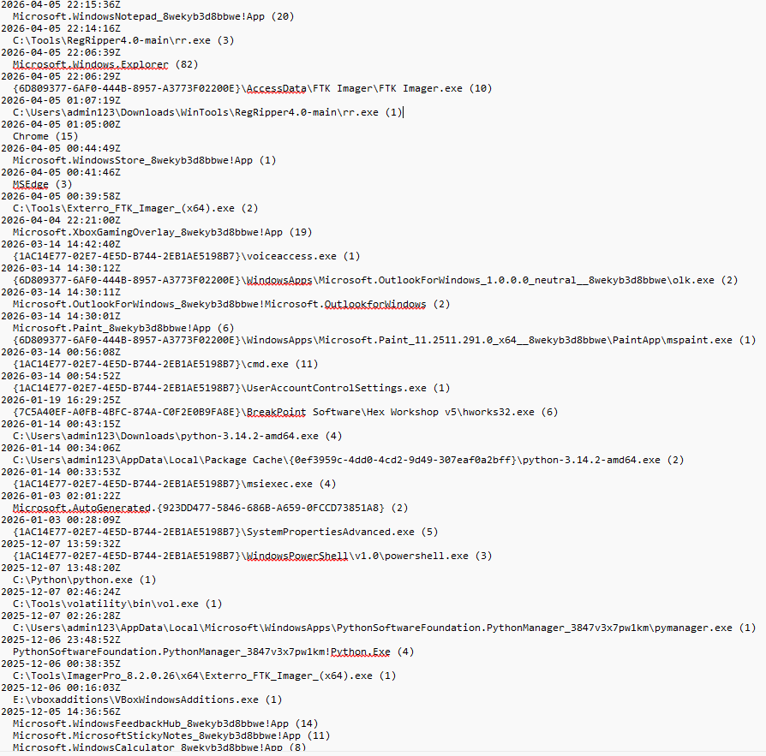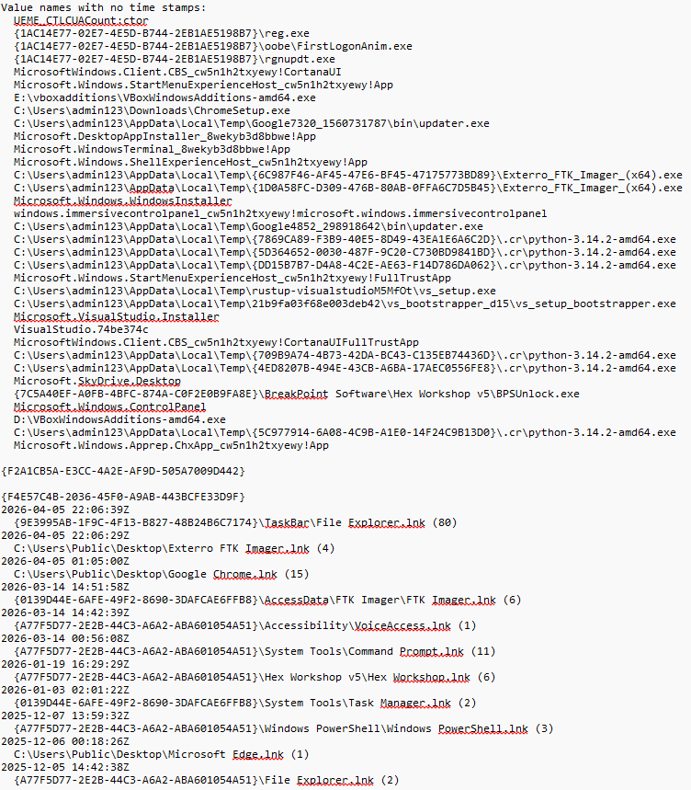
- Identify the MAC addresses associated with devices or drives used by this user.
  - 80:6F:6F:6E:69:63
  - F0:8A:00:00:00:00
  - 08:00:27:8A:B2:A6
  - 06:1B:9C:30:5F:9E
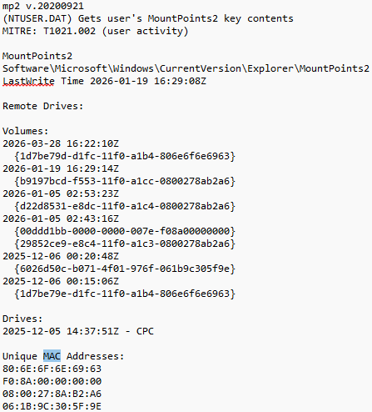
- List the recent documents accessed by this user.
  - Registry Files
  - systemdata.txt
  - SYSTEM
  - softdata.txt
  - samdata.txt
  - samdata.log
  - SAM
  - SAM.LOG1.FileSlack
  - src
  - main.rs
  - secdata.txt
  - SOFTWARE
  - SECURITY
  - SYSTEM
  - Downloads
  - Tools
  - WinTools.zip
  - ms-gamingoverlay:///
  - kglcheck/
  - symbols
  - Memsamples
  - Test2.mem
  - Test2.zip
  - test1.E01
  - C:\
  - New folder
  - windows.zip
  - vol3
  - volatility3-develop.zip
  - windows
  - __init__.py
  - volatility3-develop
  - vol.py
  - HexEditor
  - Disk Partition
  - SysinternalsToolssuite
  - vboxadditions
  - AUTORUN.INF
  - autorun.sh
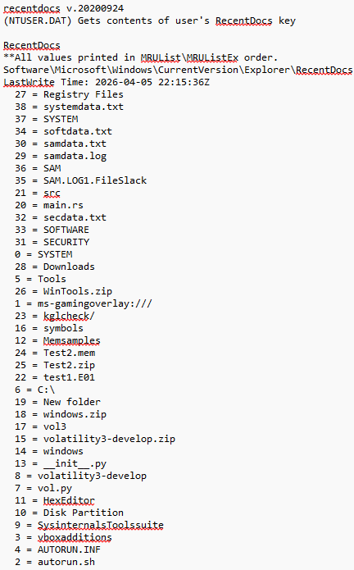
- A Jump List is a dynamic menu that contains recently accessed files, tasks, or applications (e.g., Word or Excel files from the Start menu). Identify and describe the JumpList contents for this user.
  - File Explorer.lnk
Last accessed – 2026-04-05 @22:06:39
Indicates that the user frequently uses File Explorer from the taskbar

  - Exterro FTK Imager.lnk
Last Accessed - 2026-04-05 @22:06:29
User launched Exterro from the .exe in file explorer or from a desktop shortcut
  - Google Chrome.lnk
Last Accessed – 2026-05-05 @01:05:00
User launched Google Chrome from the Desktop shortcut or .exe in file explorer
  - FTK Imager.lnk
Last Accessed – 2026-03-14 @14:51:58
FTK Imager was launched again, showing repeated usage of forensic tools. This launch however, was from a shortcut other than the desktop or direct .exe file
  - VoiceAccess.lnk
Last accessed - 2026-03-14 14:42:39
Accessibility tool opened from Start Menu
  - Command Prompt.lnk
Last Accessed - 2026-03-14 00:56:08
Shows CMD was launched from Start Menu -> System Tools
  - Hex Workshop.lnk
Last Accessed - 2026-01-19 16:29:29
Indicates use of the Hex Workshop forensic editor
  - Task Manager.lnk
Last Accessed - 2025-12-07 13:59:32
Opened from Start Menu -> System Tools.
  - Windows PowerShell.lnk
Last Accessed - 2025-12-06 00:18:26
Shows PowerShell was launched from a shortcut.
  - Microsoft Edge.lnk
Last Accessed: 2025 - 12-05 14:36:41
Indicates Edge was opened from a desktop/taskbar shortcut.

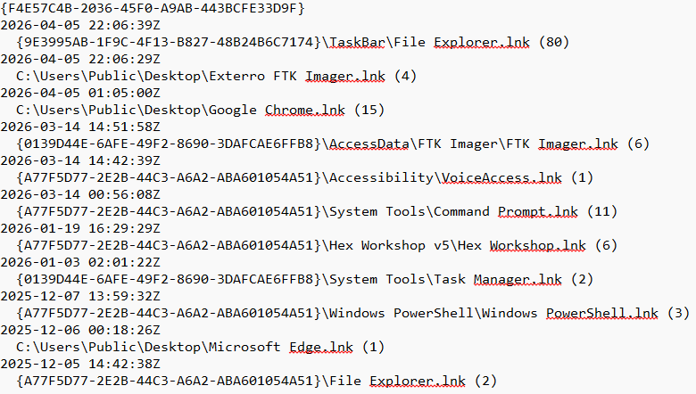

Q3. 15 Points
Using the WinPrefetchView (WinPrefetch utility), analyze the provided Prefetch folder.
Note: By default, the tool loads your system’s Prefetch files. To analyze the provided prefetch folder, go to:
Options → Advanced Options and select the given Prefetch folder.
After loading the dataset:
- Locate all Prefetch entries related to the curl utility.
- Examine each entry carefully.
Answer the following:
- How many times was the curl utility executed in total? If multiple Prefetch files exist for curl, include all of them in your count.
  - CURL.EXE-392959E8.pf | Run Count: 1 | Path: C:\Windows\System32\curl.exe
  - CURL.EXE-DD3881F2.pf | Run Count: 3 | Path: C:\CURL\BIN\curl.exe
- Which specific Prefetch file(s) did you use to determine this?
  - The prefetch files used to determine this were CURL.EXE-392959E8.pf and CURL.EXE-DD3881F2.pf as they are the only two CURL related files in the dataset.

Q4. 25 Points
Jimmy is suspicious that his computer might be hacked. He performed a memory dump of his system and ran several Volatility commands. The outputs below were generated from different Volatility plugins. Study the outputs carefully and determine what is wrong with Jimmy's computer. There may be rogue processes running, suspicious parent-child relationships, unexpected network connections, abnormal numbers of process instances, and misleading process names. Correlate the evidence across the plugin outputs. Find at least 6 such instances.

psscan Output
Volatility Foundation Volatility Framework 2.6
Offset(P) Name PID PPID PDB Time created Time exited
------------------ -------------------- ------ ------ ---------- ------------------------------ ------------------------------
0x000000003e2d7060 System 4 0 0x1a3c000 2026-04-02 13:41:18 UTC+0000
0x000000003f09d4e0 smss.exe 340 4 0x1b22000 2026-04-02 13:41:19 UTC+0000
0x000000003f1a01c0 smss.exe 404 4 0x1b2d000 2026-04-02 13:41:20 UTC+0000
0x000000003f22b120 smss.exe 468 4 0x1b39000 2026-04-02 13:41:21 UTC+0000
0x000000003f2d3b40 csrss.exe 548 404 0x1c10000 2026-04-02 13:41:22 UTC+0000
0x000000003f35f060 wininit.exe 620 404 0x1c85000 2026-04-02 13:41:24 UTC+0000
0x000000003f3fe1a0 csrss.exe 628 468 0x1cad000 2026-04-02 13:41:25 UTC+0000
0x000000003f4870c0 winlogon.exe 700 468 0x1d02000 2026-04-02 13:41:27 UTC+0000
0x000000003f52a1e0 services.exe 780 620 0x1d81000 2026-04-02 13:41:29 UTC+0000
0x000000003f5aef80 lsass.exe 804 620 0x1dd0000 2026-04-02 13:41:30 UTC+0000
0x000000003f640a20 svchost.exe 940 780 0x1e41000 2026-04-02 13:41:41 UTC+0000
0x000000003f6bba20 svchost.exe 988 780 0x1eb2000 2026-04-02 13:41:43 UTC+0000
0x000000003f74a460 explorer.exe 1504 1468 0x20e1000 2026-04-02 13:43:15 UTC+0000
0x000000003f7b8a20 explorer.exe 1612 1576 0x2172000 2026-04-02 13:44:02 UTC+0000
0x000000003f843860 explorer.exe 1720 1688 0x2203000 2026-04-02 13:44:27 UTC+0000
0x000000003f8c61e0 notepad.exe 1884 1612 0x2280000 2026-04-02 14:05:10 UTC+0000
0x000000003f940720 cmd.exe 1948 1612 0x22f2000 2026-04-02 14:06:42 UTC+0000
0x000000003f9b0f20 chrome.exe 2056 1612 0x2366000 2026-04-02 14:07:19 UTC+0000
0x000000003fa41980 scvhost.exe 4120 1884 0x2415000 2026-04-02 14:08:01 UTC+0000
0x000000003fac0240 svch0st.exe 4216 780 0x2480000 2026-04-02 14:08:12 UTC+0000
0x000000003fb4c660 conhost.exe 4308 1948 0x24f7000 2026-04-02 14:08:15 UTC+0000
0x000000003fbdff40 System 888 780 0x2579000 2026-04-02 14:08:30 UTC+0000
0x000000003fc5a220 rundll32.exe 4472 4120 0x25f1000 2026-04-02 14:09:03 UTC+0000
0x000000003fce4040 powershell.exe 4556 1948 0x2669000 2026-04-02 14:10:21 UTC+0000
pstree Output
Volatility Foundation Volatility Framework 2.6
Name Pid PPid Thds Hnds Time
-------------------------------------------------- ------ ------ ------ ------ ------------------------------
0x000000003e2d7060:System 4 0 98 612 2026-04-02 13:41:18 UTC+0000
. 0x000000003f09d4e0:smss.exe 340 4 2 29 2026-04-02 13:41:19 UTC+0000
. 0x000000003f1a01c0:smss.exe 404 4 2 31 2026-04-02 13:41:20 UTC+0000
.. 0x000000003f2d3b40:csrss.exe 548 404 9 482 2026-04-02 13:41:22 UTC+0000
.. 0x000000003f35f060:wininit.exe 620 404 3 79 2026-04-02 13:41:24 UTC+0000
... 0x000000003f52a1e0:services.exe 780 620 7 214 2026-04-02 13:41:29 UTC+0000
.... 0x000000003f640a20:svchost.exe 940 780 13 326 2026-04-02 13:41:41 UTC+0000
.... 0x000000003f6bba20:svchost.exe 988 780 11 301 2026-04-02 13:41:43 UTC+0000
.... 0x000000003fac0240:svch0st.exe 4216 780 4 62 2026-04-02 14:08:12 UTC+0000
.... 0x000000003fbdff40:System 888 780 2 41 2026-04-02 14:08:30 UTC+0000
... 0x000000003f5aef80:lsass.exe 804 620 9 587 2026-04-02 13:41:30 UTC+0000
. 0x000000003f22b120:smss.exe 468 4 2 30 2026-04-02 13:41:21 UTC+0000
.. 0x000000003f3fe1a0:csrss.exe 628 468 10 501 2026-04-02 13:41:25 UTC+0000
.. 0x000000003f4870c0:winlogon.exe 700 468 4 117 2026-04-02 13:41:27 UTC+0000
... 0x000000003f74a460:explorer.exe 1504 1468 24 812 2026-04-02 13:43:15 UTC+0000
... 0x000000003f7b8a20:explorer.exe 1612 1576 27 896 2026-04-02 13:44:02 UTC+0000
.... 0x000000003f8c61e0:notepad.exe 1884 1612 3 104 2026-04-02 14:05:10 UTC+0000
..... 0x000000003fa41980:scvhost.exe 4120 1884 6 131 2026-04-02 14:08:01 UTC+0000
...... 0x000000003fc5a220:rundll32.exe 4472 4120 5 94 2026-04-02 14:09:03 UTC+0000
.... 0x000000003f940720:cmd.exe 1948 1612 2 58 2026-04-02 14:06:42 UTC+0000
..... 0x000000003fb4c660:conhost.exe 4308 1948 2 47 2026-04-02 14:08:15 UTC+0000
..... 0x000000003fce4040:powershell.exe 4556 1948 7 123 2026-04-02 14:10:21 UTC+0000
.... 0x000000003f9b0f20:chrome.exe 2056 1612 19 731 2026-04-02 14:07:19 UTC+0000
... 0x000000003f843860:explorer.exe 1720 1688 25 841 2026-04-02 13:44:27 UTC+0000
sessions Output
Volatility Foundation Volatility Framework 2.6
Session(V) ID Processes
---------------- --- ------------------------------------------------------------
0xfffffa80031b9060 0 4:System, 340:smss.exe, 404:smss.exe, 468:smss.exe,
548:csrss.exe, 620:wininit.exe, 780:services.exe, 804:lsass.exe,
888:System, 940:svchost.exe, 988:svchost.exe, 4216:svch0st.exe
0xfffffa80042c4060 1 628:csrss.exe, 700:winlogon.exe, 1504:explorer.exe
0xfffffa80043d1060 2 1612:explorer.exe, 1884:notepad.exe, 1948:cmd.exe,
2056:chrome.exe, 4120:scvhost.exe, 4308:conhost.exe,
4472:rundll32.exe, 4556:powershell.exe
0xfffffa80044eb060 3 1720:explorer.exe
netscan Output
Volatility Foundation Volatility Framework 2.6
Offset(P) Proto Local Address Foreign Address State Pid Owner Created
------------------ ------ ------------------------- ------------------------- ---------------- ------ -------------- ------------------------------
0x000000003d144010 TCPv4 0.0.0.0:135 0.0.0.0:0 LISTENING 940 svchost.exe 2026-04-02 13:41:45 UTC+0000
0x000000003d144b80 TCPv4 0.0.0.0:445 0.0.0.0:0 LISTENING 4 System 2026-04-02 13:41:20 UTC+0000
0x000000003d145120 TCPv4 10.0.2.15:49722 185.199.110.153:5555 ESTABLISHED 4120 scvhost.exe 2026-04-02 14:08:22 UTC+0000
0x000000003d1457a0 TCPv4 10.0.2.15:49723 91.219.236.10:5555 SYN_SENT 4120 scvhost.exe 2026-04-02 14:08:29 UTC+0000
0x000000003d146020 TCPv4 10.0.2.15:49724 203.0.113.77:5555 SYN_SENT 4120 scvhost.exe 2026-04-02 14:08:34 UTC+0000
0x000000003d146700 TCPv4 10.0.2.15:49740 172.217.5.110:443 ESTABLISHED 2056 chrome.exe 2026-04-02 14:07:27 UTC+0000
0x000000003d146ec0 TCPv4 10.0.2.15:49751 198.51.100.44:4444 ESTABLISHED 4216 svch0st.exe 2026-04-02 14:08:44 UTC+0000
0x000000003d1476a0 TCPv4 127.0.0.1:5555 127.0.0.1:49801 ESTABLISHED 4472 rundll32.exe 2026-04-02 14:09:15 UTC+0000
0x000000003d147e80 UDPv4 0.0.0.0:68 *:* 988 svchost.exe 2026-04-02 13:41:44 UTC+0000
0x000000003d148500 TCPv6 [::]:3389 [::]:0 LISTENING 888 System 2026-04-02 14:08:37 UTC+0000

There are multiple red flags within Jimmy’s system, many more than 6, some of which show that remote access has likely been established within his system, and that there is likely to be malware present on the system. The following red flags were established and have been separated by each scan type.

psscan
  - Multiple smss.exe processes
    - psscan shows 3 smss.exe processes running simultaneously
    - There should only be one smss.exe process running as the Session Manager
    - Due to the multiple instances, it is likely that there is malware impersonating smss.exe occurring
  - Multiple explorer.exe processes
    - psscan shows 3 explorer.exe processes
    - A single logged on user likely only has one explorer.exe process running, however, since Jimmy is scanning his system using these commands, it is possible that he left multiple explorer windows open for results
    - If Jimmy was not the only user with open explorer.exe processes however, this suggests that hidden sessions or malware persistence is occurring
  - Fake process named scvhost.exe
    - psscan lists a process named scvhost.exe
    - This was a misspelling by an attacker who attempted to impersonate svchost.exe, a legitimate Windows process
  - Fake process named svch0st.exe
    - psscan lists a process named svch0st.exe
    - This is another malware impsersonation attempt by an attacker but was misspelled with a zero instead of “o”.
  - Second “System” process
    - psscan shows two System processes with different PID’s
    - Windows should only have one System process running, this suggests that malware is again attempting to disguise itself

pstree
  - Impossible parent-child relationship: notepad.exe has child scvhost which then has child rundll32.exe
    - svchost cannot be run by Notepad as it’s a service-host process
    - scvhost.exe is another misspelled version of svchost
    - The fake svchost.exe is launching rundll32.exe which looks like a malware execution chain

sessions
  - Fake svch0st.exe running in Session 0
    - Session 0 is used only for core system processes
    - This indicates that privilege escalation has likely been successfully done by an attacker

netscan
  - scvhost.exe is making 3 outbound connections to port 5555 via the following connections
    - 185.199.110.153:5555
    - 91.219.236.10:5555
    - 203.0.113.77:5555
    - Port 5555 is commonly used for botnets and RATs

  - svch0st.exe is connected to 198.51.100.44:4444
    - Established connection with port 4444
    - Port 4444 is commonly used with malware such as Metasploit

  - rundll32.exe is communicating with localhost:5555
    - rundll32 should not connect to open networks
    - rundll32 in this case is the child of the fake svchost.exe that was launched by notepad, this is likely communicating back to the fake svchost.exe which is then transmitting the data

